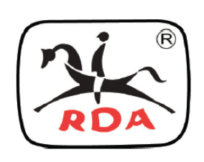
Riding for the Disabled Association (NSW) Ryde Centre
2021 Volunteer Training Resource

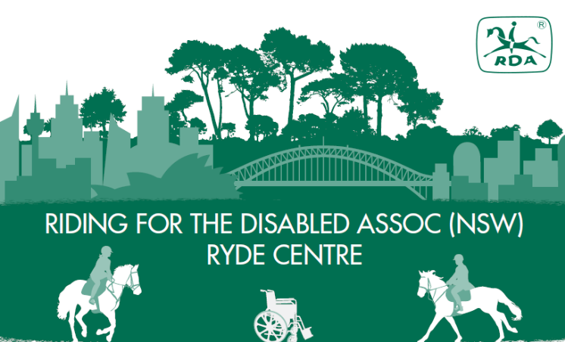

‘Marsfield Park”
118-120 Culloden Road Marsfield
P 02 9868 2223
E ryde.rda.rider@gmail.com
Website | Facebook | Instagram
Contents
General Information 4
Welcome to Volunteering at RDA Ryde Centre 4
About Riding for the Disabled 4
History of RDA NSW 5
The Basic Aims of RDA 5
Funding 5
Our Centre 5
Our Riders 6
Our Coaches 6
RDA NSW Volunteers 7
RDA NSW Commitment to Volunteers 7
RDA NSW Code of Conduct 8
The Rights and Responsibilities of an RDA NSW Volunteer 9
RDA NSW Risk Management and Safety Policy 10
The RDA “Way” 12
Catching and releasing a horse safely 12
Tying up safely 13
Leading a horse effectively 14
Grooming a horse safely 16
Putting on and removing a rug safely 17
Saddling a horse safely 18
Putting on the bridle safely 20
Mounting and dismounting 21
Side-walking effectively 23
Feeding an RDA Horse 24

General Information

Welcome to Volunteering at RDA Ryde Centre
Many thanks for volunteering to help at RDA NSW Ryde Centre.
There are many activities that you can help with:
- Caring for the horses
- Training horses and ponies
- Leading horses or assisting riders in the programme
- Helping with activities for unmounted riders
- Assisting the Coach with the day’s paperwork
- Refreshment host/hostess
- Fundraising
- Committee work
- Assisting with the organisation of events such as Dressage days
- Gardening, maintenance, yard management
Those listed above are but a few of the many jobs needing to be done to keep the Centre operating. If you want to help but don’t want to assist in the riding classes, there are many other tasks where Ryde needs assistance.
The Coach is completely responsible for the conduct of every RDA session.
The role of the Volunteer helper is to assist the RDA Coach implement the riding programme.

About Riding for the Disabled
Riding for the Disabled Association (RDA) NSW is a voluntary organisation which provides riding instruction and other activities associated with riding and driving for people with disabilities. There are presently 36 active Centres in NSW, catering for over 1600 riders with disabilities. RDA NSW is administered by a Board of Directors and a State Council which is comprised of the Board and Regional Representatives. There are ten Regional Representatives who are responsible for the Centres in their region. Coach development and training is administered by the Coaching and Safety Panel (CASP).

You can find additional information about RDA NSW at:
www.rdansw.org.au

History of RDA NSW

The philosophy of using horses for people with a disability is not new. The Greeks used horses for rehabilitating wounded soldiers in the fifth century BC and indeed throughout history, riding has been prescribed as a means of improving the mental and physical well-being of people with disabilities.

Last century, therapeutic riding was recognised by Dame Agnes Hunt, who established the first orthopaedic hospital in the United Kingdom. Dame Agnes Hunt understood the real need for laughter and companionship in the recovery of health, and the importance of horses and riding for her patients. Her work was followed up with soldiers who had been disabled during both world wars and many hospitals deliberately encouraged riding as a means of therapy.

At the 1952 Helsinki Olympic Games, Madame Liz Hartel, a Dane who had contracted polio and was normally confined to a wheelchair, left her chair for her horse’s back and then proceeded to win a silver medal in the dressage event. This achievement naturally received worldwide attention, focusing on the fact that “It is ability that counts, not disability”. Her courage and achievement gave encouragement to many people.

Following the Games, Riding for the Disabled centres began springing up in countries throughout the western world. The first Australian centre was started in 1964 by Mr and Mrs Peter McIntyre, who with the help of a few friends, started to give riding therapy to people with disabilities by inviting them to their property just outside Brisbane. South Australia commenced operation in 1970 and was followed by Victoria in 1971. In 1972 Mrs Pearl Batchelor, a riding school instructor and Mrs Nan Everingham, a physiotherapist founded the New South Wales branch. Western Australia, Canberra and Tasmania all started in the following years.

The Basic Aims of RDA NSW

The primary objective of RDA NSW and the Ryde Centre is to provide most people who have a disability the opportunity to ride and enjoy all the activities connected with horse riding. For people with a disability, riding is both therapeutic and recreational. RDA NSW is in fact one of the few organisations that cater for people with a wide range of disabilities.

Funding

Our Centre is run entirely by volunteers and is responsible for raising our own funds. Craft stalls, sales of Chocolates and Christmas cards, theatre parties, sponsorships and donations etc are methods of raising money. The horses may be purchased; quite often they are donated or leased long term. They have to be fed and expensive saddlery and safety equipment purchased.

It costs upwards of $5,000to keep a horse per year and sponsorship is an excellent way of helping with the expense of feed, vet bills and farriers. Because of the high costs, t horses may be co-sponsored by individuals or groups such as local businesses, service clubs, and student councils of local schools.

Our Centre

RDA Ryde Centre began in 1984 in the grounds of the Royal Rehabilitation Centre, Ryde, where we worked with thousands of riders and volunteers for over 24 years.

The relocation and construction of our new home at Marsfield Park signalled the start of decades of enjoyment for hopefully thousands more riders and volunteers.

Our horses stay at the centre all year except during the Christmas break when they are turned out to pasture for a well-earned rest.

Our Riders

Riders are accepted from all disability groups. Every rider must have a medical consent form signed by their doctor. They are assessed prior to commencing riding so that a suitable individual program can be developed for each rider. Some riders with more severe disabilities are assisted initially by up to two trained helpers and a leader, however, many graduate to riding independently and some to competition level.

RDA Riders include people with: Cerebral Palsy, Spina Bifida, Multiple Sclerosis, Muscular Dystrophy, multiple injuries, amputees, Stroke, Arthritis, Down Syndrome, vision and hearing impairment, intellectual and emotional disabilities, learning difficulties and behavioural issues.
With the help of RDA, people living with any of these disabilities can enjoy riding as it provides a significant aid in treatment and rehabilitation.

Our rider’s ages have ranged from 3 years to 73 years. Disabilities are varied and we prefer to focus on ability, not disability. Groups of riders may come from schools or residential groups. Our younger Saturday riders usually come with their parents with older riders often coming interdependently.

There are strict safety standards in RDA and riders are required to wear Australian Standards Association approved helmets (3838) and correct footwear, which may be provided by the centres. Special equipment is used occasionally; however, RDA attempts to keep conditions as close to natural as possible to encourage the riders to achieve a good position through the use of their own body.

Some of the benefits our riders may enjoy include:
- Improved balance and posture
- Promotion of body awareness
- Increased planning and decision making
- Improvement in gross and fine motor skills
- Increased motivation and learning, and development of reading and speech through games
- Development of eye-hand co-ordination
- Sensory stimulation through activity and surroundings
- Overcoming phobias such as heights and animals
- Increased self-confidence and self-esteem and improved social integration
- Improvement in memory and concentration
- Enhanced mobility and access to new experiences
- Development of language and communication skills
- Learning the value of rules eg: safety and discipline
- Personal challenge leading to achievement of goals
- Learning a skill that many able-bodied people don’t have
- Learning about animal welfare by contact with animals
- Participation and opportunity for competition
- Being given the right to take controlled risks
- The promotion of a general feeling of well-being

Our Coaches

Our coaches are all qualified RDA NSW Coaches. They are certified First Aiders (updated every three years) and have skills in horsemastership, teaching and management of the centre. Coaches are assessed on these subjects and are graded as Assistant Coach, Coach or Senior Coach.

The Coach of the Day has full responsibility for the horses, riders and volunteers. The Coach will brief the volunteers before each riding session and at the end of the day discuss the progress of the riders with the volunteers. Discussion with carers or school staff regarding the riders is the responsibility of the coaches only.

RDA NSW Volunteers

Volunteers don’t need any prior knowledge of horses; they learn on the job. Jobs may include cleaning up yards, feeding, grooming and tacking up horses, making cups of tea, assisting riders to prepare for class, helping with games in class, or “side walking”, to assist or instil confidence in the rider. There are also countless ‘admin’ and fundraising tasks which are the domain and responsibility of volunteers.

Some important things to note:
• Always sign the “Volunteers Day Book” (this is for insurance purposes).
• Learn how to tie a quick release knot.
• Always check with a coach before photographing any rider.
• Never wrap a lead rope around your hand. A horse is stronger than you and you risk broken fingers if he decides to pull away.
• When a horse is tied up, don’t walk under his neck, go behind or unclip his lead rope and walk around the front.
• Riders must not be mounted or dismounted without the supervision of the coach or appointed experienced volunteers.
• When leading a horse in class, always keep about two horse lengths between you and the horse in front. If you are getting left behind, you may have to cut corners in order to catch up.
• If you are in control of the horse, you must not assist the rider when mounting or dismounting.
• When leading, the horse is your responsibility if there are side-walkers. If there are no side-walkers, the wellbeing of the rider comes first.
• Move out of the class into the centre of the arena if there is a problem with your horse or rider. The coach can then address the problem.

RDA NSW Commitment to Volunteers
To ensure the volunteer’s experience is satisfying and rewarding and complies with Federal and State legislation and our Duty of Care, RDA NSW commits to the following:
- State and acknowledge the contribution of volunteers in RDANSW documentation
- Recognise the achievement of volunteers
- Provide insurance cover
- Make volunteers aware of, and provide them with, a copy of the RDANSW Volunteers information and other documents relating to RDANSW Volunteer policies
- Offer volunteers the choice of work in their preferred areas.
- Provide orientation, training and information to promote skill development in all aspects for RDANSW.
- Acknowledge the rights of volunteers
- Provide access to RDANSW’s Code of Conduct and dispute resolution process
- Provide a safe volunteering environment
- Provide appropriate levels of support and management for volunteers
- Treat all volunteers equally
- Ensure confidentiality of person details in accordance with the National Privacy Act 2001
- Implement Equal Opportunity and Anti Discrimination legislation
- Attempt to keep volunteers informed on changes to the organisation
- Promote the SunSmart policy

RDA NSW Code of Conduct

RDA NSW provides a quality Duty of Care while implementing all RDA activities – the conduct of all participants must be of a standard that will be a positive influence on riders’ behaviour. This Code of Conduct shall apply to all members, officials, office bearers, volunteers, riders, parents and carers, participating in or in attendance at all activities conducted under the control of, or when representing and RDANSW Centre.

Persons subject to this Code shall...
- Respect the rights, dignity and worth of every person regardless of their gender, ability, cultural background or religion.
- Respect riders’ confidentiality.
- Use age appropriate behaviour and language with riders.
- Refrain from using profane, insulting, harassing or otherwise offensive language, hand signals or other gestures.
- Understand that coaches’/volunteers’ intentions and riders’ interpretation of “touching” will be influenced by cultural differences and religious implications.
- Avoid unaccompanied and unobserved activities with riders, especially undressing and personal hygiene.
- Not drink, be affected by, or in possession of alcohol or non-prescription drugs while responsible for implementing any RDA horse programme.
- Not engage in any other conduct, either on or in the vicinity of RDA activities, considered prejudicial to the best interests of RDA or in contravention of the Constitution of this Association.

Please keep in mind we are ALL volunteers at Ryde Centre.
We all have many commitments and responsibilities outside the Centre however please leave any cares and concerns at the gate and enjoy being with our horses and riders.
By working together as a team we can achieve great things!

The Rights and Responsibilities of an RDA NSW Volunteer

As an RDA NSW volunteer you have the right to...
- Be assigned a suitable job and to say NO to any task you are unable or would prefer not to do
- Express opinions, be listened to and have your opinions respected
- Receive adequate information of what is expected of you
- Ask questions about anything you may not understand
- Receive support and training
- Have your personal details kept in a confidential manner
- Work in a safe environment
- Be reimbursed for agreed out-of-pocket expenses
- Be advised of insurance cover
- Be treated fairly
- Have access to Dispute Resolution Provisions

As an RDA volunteer you are responsible for...
- Signing the “Working with Children” check as required by law
- Arriving at agreed times
- Signing and noting time in “Attendance Book” when you arrive or leave
- Notifying the Coach or committee if you are unable to attend a planned activity
- Respecting rider confidentiality
- Adhering at all times to the safety requirements and regulations of RDA
- Following the directions of the Coach when in a riding programme
- Providing feedback where appropriate
- Asking for support when needed
- Informing RDA of any medical condition or special needs you have, which may affect your ability to do certain tasks
- Reporting hazards, injuries or risk management issues
- Attending ongoing training
- Advising your Centre of any change of address, phone number, etc

RDA NSW Risk Management and Safety Policy

For more information and risk management assessment forms, refer to the RDA NSW Administration Manual
Coaches and the volunteer co-ordinator can provide access to this document which is kept in the office.
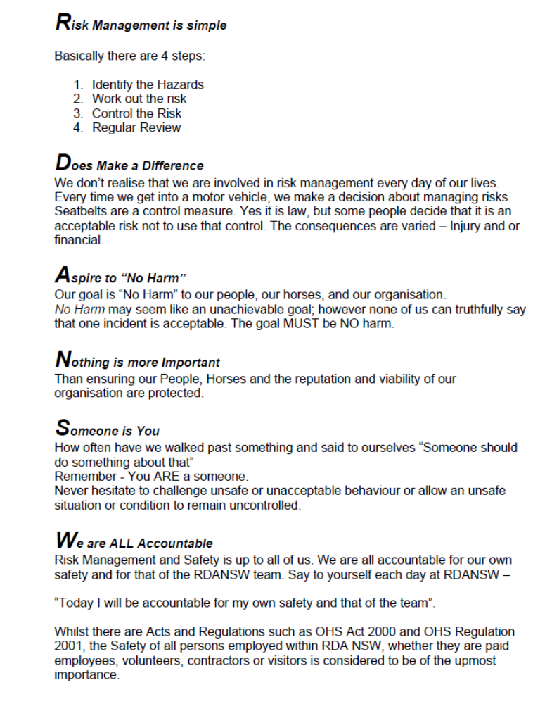

The RDA “Way”

Catching and releasing a horse safely
Rule
Always make sure the horse knows you are coming. Make a small noise or speak its name.
Catching a horse
- Approach the horse calmly and quietly
- Carry the head collar and rope either on your shoulder or in your hand by your side.
- Always approach the horse from an angle where it can see you
- On reaching the horse, stroke it on the shoulder or neck
- Allow it to smell you before placing the lead rope over the horse’s neck
  - Take rope under the horse’s neck then over
  - Slip the headcollar over the horse’s nose
  - Then pass the head strap behind the horse’s ears and do up
- Quietly remove the lead rope from around the horse’s neck
- Hold the lead rope with the right hand about two hands width from the clip
- Hold the other end loosely folded in the left hand
  - NEVER allow the lead rope to become wrapped around your hand
- Lead the horse quietly to the gate, walking at or slightly behind the horse’s head. This allows the horse maximum vision
On leaving the yard, make sure that the gates are closed (including the connecting gates between each yard).
Releasing a horse
- Lead the horse to its yard.
- Once through the gate, close the gate
- Lead the horse a short distance away from the gate
- Turn the horse to face the gate
- Place the lead rope over the horse’s neck
  - Take rope under the horse’s neck then over
  - Facing the same way as the horse
  - Undo the head strap
  - Slide the nose band off the horse’s nose
- Before removing the lead rope, stroke the horse
- Quietly remove the lead rope and step away from the horse
- Collect up the head collar and lead rope so that it does not trail on the ground and leave the yard
Note: If turning two or more horses out in the same yard, wait until all handlers have reached step 6 before removing the lead rope.
On leaving the yard, make sure that the gates are closed (including the connecting gates between each yard).

Tying up safely
Rule 1
Always tie the horse to something solid and firm. Never tie a horse to anything moveable, or anything that would become moveable if broken by a firm pull.
Rule 2
Tie up the horse with a small loop of string or twine attached to the unmoveable object.
At RDA Ryde, the horses should always be tied up to string or if string not available, a single strand of baling twine (ensure that it will break if strongly tugged) that is attached to a metal ring or the fence. Do NOT tie the horse directly to the rail by the lead rope or bridle.
Rule 3
Always use a quick release knot.
To tie a quick release knot –
- Bring a loop of the lead rope through the loop of the string
- Twist the loop once.
- Bring a loop of the loose end of the lead rein through the loop.
- Tighten by pulling on the other end of the lead rein (the end attached to the horse).
- If the loose end of the lead rein is very long, continue to loop the loose end through so that the end is not on the ground.
- If the horse is likely to play with the lead rein and untie itself, pass the end of the rein through the last loop.
Rule 4
Tie the horse up as close to its normal nose height as possible. Keep the rope fairly short – just long enough so that it can stand comfortably. Too long and it may get its foot over it, or its head under it and give itself a fright.
- Make sure that the horse has enough length of lead to be able to move its head (a rough guide is to make the first loop about midway down the lead rein).
Rule 5
Never tie a horse up by its bridle. If it pulls back, the horse may hurt its mouth, and the bridle may well be broken.
At RDA Ryde all horses should have a headcollar under their bridle to which a lead rein can easily be clipped. The only exception will be when the horses are being used for a dressage class or a competition.

Leading a horse effectively
Rule
Leaders, at all times, have responsibility for the horse and rider they are leading.
A leader must remain with the horse they are leading and must not leave to attend to another horse or rider with a problem.
The leader is fully responsible to their rider and must be aware of their position in the saddle and be prepared to stop if the rider has a concern or becomes unbalanced.
- The leader may even have to draw the Coach’s attention if a problem is unnoticed by the Coach.
Leading a horse effectively
- At RDA it is the usual practice to lead from the head collar which is left on under the bridle.
- The leader should be walking at the horse’s shoulder unless there is a side walker on that side in which case the leader should be walking closer to the horse’s head.
  - When walking closer to the horse’s head, it is important to remain out the horse’s line of sight so that the horse has clear vision
- At RDA Ryde, it is usual to lead from the near/left side of the horse.
- Hold the lead rope about 60cm (2 hand’s width) item 7 in catching a horse says 2 hands width from the clip in your right hand with your knuckles upright
- Hold the remainder of the lead rein in your left hand folded across your palm
  - NEVER allow the lead to become wrapped around your hand
- ALTERNATELY hold the end of the lead rope and surplus lead across the body in the left hand leaving the right hand free to help the rider or to stop the horse by placing the right and in the centre of the horse’s chest.
- Face forward, stay level with the horse’s shoulder (where possible).
- Ask the horse to walk forward, using the voice command “Walk on”.
  - Push your right hand forward as you give the command
  - When the horse moves forward, move forward with it.
  - Do not turn around to face the horse or try to drag the horse.
  - When moving off, always walk straight forward a few steps before turning the horse.
- To turn the horse, push it away from you so that you remain on the outside of the horse where possible.
  - If turning to the left, do not pull the horse around you. Walk a small circle instead.
- As leader, it is your responsibility to ensure that the horse responds appropriately to the rider’s signals.
  - Wait until the rider gives a signal to move off before asking the horse to walk forward.
  - Allow the rider to pull on the rein or say “Whoa” before halting the horse.
  - Allow the rider to pull on the rein to turn the horse before turning the horse.

Grooming a horse safely
Rule
Always tie the horse to something solid and firm using a quick release knot and twine. Never tie a horse to anything moveable, or anything that would become moveable if broken by a firm pull.
Reasons for grooming
- It helps keep the skin healthy
- It keeps the coat shiny and clean
- It gives us a chance to check the horse over
- It establishes a bond between horse and rider/handler
- It helps maintain and promote good health
- It cleans the horse
- It provides the horse with a massage
- It provides us with an opportunity to check legs and feet
Grooming a horse
- Tie the horse up using a quick release knot
- Using the body brush, brush the horse starting behind the head and working towards the tail
- ALWAYS brush in the same direction that the hair grows
  - Keep one hand on the horse while brushing with the other
- When brushing the horse’s belly, watch for any reaction from the horse
  - Many horses are ticklish on the belly
- Make sure that you check that all dirt has been removed from the girth area
  - After brushing, run your hand over the area to check
  - Dirt left in this area can result in girth galls areas where the hair has been rubbed away, causing the horse to become sore and unable to be ridden)
- Brush down each leg, keeping one hand on the horse as you do so
- Use a damp sponge to wipe over the horse’s eye and nostrils
- Use the hoof pick to clean each hoof
  - Run your hand down the horse’s leg to the fetlock and gently grasp the fetlock
  - Ask the horse to lift its leg by gently tugging on the fetlock
  - Support the hoof with one hand
  - With the other, using the metal hook, remove the dirt from the sole of the hoof
  - Work from beside the frog to the front of the hoof
  - Use the brush of the hoof pick to brush out the hoof
  - Once clean, gently lower the hoof to the ground
- Repeat for the remaining hooves
- Finger comb mane and tail removing any burrs and grass/hay
  - Do NOT use a brush or comb on the mane or tail without permission from the coach
- Return all equipment to grooming box
- Only use the equipment that belongs to that horse. This minimises the risk of infection or disease

Putting on and removing a rug safely
Rule
Always tie the horse to something solid and firm using a quick release knot OR have another person hold the horse. Never tie a horse to anything moveable, or anything that would become moveable if broken by a firm pull.
Putting on a rug
- Fold the rug in half inside out and front to tail
- ALWAYS ensure the leg straps are fastened
- Lift the folded rug carefully over the horse, placing it slightly in front of the withers. It can then be pulled slightly backwards
- Unfold the rug and slide it back to within a few centimetres of the final position
- Do up the leg straps. When doing up the leg straps:
  - The left leg strap should be fastened to the left ‘D’ ring
  - The right leg strap should be threaded thru the left leg strap and fastened to the right ‘D’ ring to prevent the rug from slipping
  - Make sure the clips are turned inwards, towards the horse when fastened.
- Do up the front chest strap/s
- Do up the belly straps, ensuring they crossover under the horse and are not twisted
- Do up the straps of the neck rug
- Do NOT shift the rug forward once it is on as it pulls the hair in the wrong direction.
Untie the horse and/or remove the head collar.
On leaving the yard, make sure that the gates are closed (including the connecting gates between each yard).
Removing a rug
- Undo belly straps
- Undo straps on neck rug
- Undo front chest strap
- Undo each leg strap
  - ALWAYS stand to one side when undoing straps
  - ALWAYS reattach strap to ‘D’ on the same side once removed from around horse’s leg
- Fold rug in half from front to tail
- Slide rug off, sliding from front to back and towards yourself
- If a fine day and horse is going out of yard, hang rug inside out over fence near gate
- If horse is remaining in yard, hang rug inside out over top rail in horse’s shelter, ensuring rug is tucked behind lower rail.
Untie horse and/or remove head collar
On leaving the yard, make sure that the gates are closed (including the connecting gates between each yard).

Saddling a horse safely
Rule
Always treat the saddle with respect. Do not put it on the ground. Place it away from the horse so that it won’t get trampled. Ensure the stirrups are up and the girth attached on the right side and laid across the seat in preparation to putting g it on the horse.
Saddling a horse
- Ensure that the area where the saddle is to sit has been brushed clean.
- Put the saddle cloth on the horse slightly forward to where it will finally sit.
- Put the saddle on the saddle cloth, also slightly forward of where it will be when riding.
  - Make very sure that there are no wrinkles in the saddle cloth under the saddle
  - The weight of the saddle is not on any seams or edges as this can cause considerable discomfort and even damage to the horse.
- Slide saddle and saddle cloth back to correct position.
  - This smoothes the horse’s hair in the direction of growth.
  - NEVER push the cloth and/or saddle against the lie of the hair.
TIP: you should be able to fit a fist between the horse’s elbow and the girth when it is done up.
- Check that the saddle is sitting correctly on both sides.
  - Check that the saddle cloth is sitting flat under the saddle and that it is an equal length on each side.
  - Check that the saddle flaps, are not rolled up and that there are no buckles caught up under the saddle.
  - Check that the saddle is straight and that the gullet is in line with the horse’s spine.
  - When walking to the other side of the horse, do not duck under the horse’s neck.
- Whilst on the offside of the horse let down the girth and check that it is not twisted.
- On return to the nearside, pull the front of the saddle cloth up into the gullet of the saddle.
- Buckle up the girth gently and loosely.
TIP: you should be able place a flat hand between the girth and the horse.
  - It should be firm enough to hold the saddle in place, but not tight.
  - If the girth has three buckles, do up the first and third straps first, leaving the middle strap until last.
  - If the girth has only two buckles, do the girth up on the first and third straps.
- When using a single buckle girth, a surcingle must be fitted.
  - The surcingle is placed over the girth and saddle and does up below the girth on the nearside.
- Leave the horse tied up until ready to commence riding.
- Prior to mounting the horse, walk the horse for a short distance.
- Recheck the girth and tighten gently.
TIP: it is tight enough if you can only get two fingers between the girth and the horse.
- Stretch the horse’s legs gently by pulling the front leg gently forward from the elbow.
- Check that buckle guards and straps tucked in, let down the stirrups.
- Once mounted, check the girth a final time and tighten if necessary.
REMEMBER the girth may need tightening at any time while riding.

Putting on the bridle safely

- Horses should not have their bridle put on until they are ready to go into the arena for class.

- If horses waiting for class or are not being used, if left in the saddling yards, they should not have a bridle on.
To put on a bridle:
- Check the bridle –
  - The bit is clean and in good condition
  - The cheek pieces are the same length
  - The throat lash and noseband are undone
- The horse should be untied and held by a lead
- Put the reins around the horse’s neck (the reins should NEVER be allowed to trail on the ground
- Face the same way as the horse.
  - Place your right hand around the horse’ nose and take hold of the cheek pieces and nose band in the right hand
  - Let the bit lie in the left hand
- Encourage the horse to open its mouth by inserting the thumb of the left hand into the gap between its teeth. Gently ease the bit into the horse’s mouth.
- Once the bit is placed in the horse’s mouth, use the left hand to ease the head piece over the horse’s ears.
  - Ease the head piece over the right ear first, then the left ear.
  - Release the right hand as you ease the head piece over the ears
  - Settle the browband comfortably in the groove below the horse’s ears
  - Gently pull the forelock out from under the browband
  - Ensure that the headpiece is sitting comfortably behind the horse’s ears.
- Do up the throat lash so that you can easily fit the width of your hand between it and the horse’s head
- Check that the bridle is sitting correctly and that the bit is sitting correctly in the horse’s mouth. If unsure, request that it be checked.
- Do up the noseband. The tightness of the noseband will be dependent on the type of noseband used.
- Place the reins over the horse’s neck.
- If the horse is not being ridden immediately however is in a class waiting for a rider, twist the reins.
  - Undo the throat lash and pass throat lash between reins. Re do throat lash.
  - Tie horse up using lead rein and quick release knot
RULE
NEVER tie a horse up by its bridle.

Mounting and dismounting
Rule
Mounting is the time when riders are most vulnerable and volunteers must be well trained in mounting safety ad procedure.
Pre-mounting safety check
Riders:
- Must be assembled in a supervised area waiting to mount
- No rider is to approach a horse or the mounting area unless accompanied by a helper.
- All riders must wear a correctly fitted helmet which confirms to the standard for equestrian helmets.
- Shoes or boots must have a smooth sole and a heel.
  - If footwear does not conform then ‘Toe stoppers’ must be fitted
- Stirrups should allow 1cm each side of the rider’s boot at its widest part
- Riders must wear long pants.
Volunteers need:
- To wear enclosed footwear
- No flapping clothes that could annoy/frighten the horses
- Sun protection if classes are held outside of the covered arena
- Mobile phones turned off
Mounting from a ramp
Leader:
- Make sure the horse has been warmed up.
- Check the girth and tighten if necessary.
- Let down stirrups.
- Bring the horse from the arena to the mounting area.
- Lead the horse into the ramp coming in parallel and close to the ramp.
- As you approach the ramp move to the side away from the ramp.
- Guide the horse in to the ramp turning the horse’s head slightly towards you and placing your free hand on the horse’s shoulder.
- Ask the horse to halt and to stand quietly.
- When the horse is standing quietly, advise the coach that the horse is ready for mounting.
- Remain at the horse’s head, standing to the side.
- Your primary responsibility to keep the horse standing quietly at the ramp.
- The person on the ‘off side’ assisting with mounting should assist rider to find their stirrup if needed
- When the rider is settled in the saddle, move the horse away from the ramp to an area where there is room to adjust stirrups.
- Halt the horse and check the girth again.
- Return to the arena and take direction from the coach.

Side-walker
- The side-walker may be the person escorting the rider to the ramp and assisting with mounting from the ‘off side’.
- Once the rider is with the coach, walk from the ramp to the side of the horse away from the ramp.
- If the rider mounts putting their foot in the stirrup, hold the other stirrup firmly close to the stirrup bar.
  - This prevents the saddle from moving as the rider puts their weight in the stirrup.
  - Holding close the stirrup bar prevents stretching of the stirrup leather.
- Be prepared to assist the rider to lift their leg over the horse.
  - This may be over the neck in the case of a rider who mounts by sitting sideways in the saddle then swinging their leg over the horse’s neck.
  - Do not allow the rider to kick the horse as they bring the leg over, this can upset/annoy the horse.
- If the rider mounts by sitting sideways in the saddle, you may need to support the rider’s back so that they feel secure as they transfer to the saddle.
- If the rider is a full lift mount, it is important to be able to take the rider’s leg on the outside and gently support it as the rider settles into the saddle.
- Remain with the rider as the horse moves away from the ramp to a safe area.
- Adjust the rider’s stirrups to the length that is most comfortable for the rider.
- Check the girth and adjust as necessary under instruction from a coach or experienced volunteer who has been delegated by the coach to assist.
- Return to the arena remaining with the rider at all times.

Dismounting
- Wherever possible the rider should dismount to the ground.
- The horse is asked to halt, and held by the leader who is standing by the horse’s head.
- Both of the rider’s feet must be out of the stirrups before dismounting.
- The rider is asked to move hands forward on the horse’s neck and leans forward.
- The coach (or designated volunteer) should be on the left side of the horse.
- The side-walker (or designated volunteer) should be on the right side of the horse.
- The side-walker assist the rider to lift their leg over the horse’s rump (if necessary).
  - As with mounting, it is important that the rider does not kick the horse while dismounting as this can annoy/upset the horse.
- ALTERNATELY, the side-walker may need to lift the rider’s leg over the horse’s neck and assists the rider to turn side-ways in the saddle facing the coach.
- The coach assists the rider to the ground.
- The side-walker comes around to the left side of the horse and accompanies the rider out of the arena.
- The rider is encouraged to thank the horse before leaving the arena.
- Once the rider has moved away from the horse. The leader runs up the stirrups and loosens the girth.
- On the coach’s command the leader takes the horse out of the arena.

Side-walking effectively
Rule
Side-walking is an important role for a volunteer.
Side-walking effectively
1. For the side-walkers to be of any benefit to the rider they must be in the correct position – i.e. level with the rider’s body.
- Too far forward and the side-walker may not be aware of the position of the rider’s position in the saddle.
- Too far back and the side-walker is not in a position to assist the rider if required should there be a problem.
- Too far back and the side-walker may also annoy the horse and cause him to display his annoyance by kicking.
2. If there is only one side-walker, they should be position on the opposite side to the leader.
- There are various holds that can be used to support a rider according to their needs.
  - At the ankle provides reassurance and prevents the leg from swinging, creating a more stable seat.
  - With an arm across the thigh, again providing reassurance and stabilising the seat.
  - Via the use of a waist-belt to support the trunk and preventing sideways movement.
  - With a hand on the chest just below the axilla (armpit) to provide greater trunk stability for riders who are unable to sit upright.
- ALWAYS request permission before using any hold. Holding without permission can be seen as assault.

Responsibilities of the side-walker in a lesson
- To give both moral and/or physical support
- To relay information from the Coach
- To assist when necessary during exercises or games
- Leaders and side-walkers should not talk amongst themselves during a lesson
- Do not lean on the horse, e.g. an arm behind the saddle or over the neck.
- Encourage independence in the rider e.g. the rider to be encouraged to ask the horse to walk, etc.
- Avoid engaging excess chitchat with riders during a class. Instead encourage the rider to focus on the Coach and the class activities.

Feeding an RDA Horse
Our horses need to be fed, their yards cleaned and possibly rugs changed twice a day. Trained volunteers are always needed to assist. If you can commit to morning or afternoon feeding even one day a week, please speak to the volunteer co-ordinator to be added to the feeding roster. Our ‘feeding’ team are probably the most popular volunteers in our horses opinions!
Some basic rules:
ALWAYS wait for other team members to arrive – do not feed on your own
- Sign Attendance Book – compulsory for insurance purposes

- Walk down to yards and check all the horses are o.k.
(a quick look over from head to toe)

- Check water is working and water bowl is clean

- Check rugs are still in place – remove or put on when necessary. Always have a headcollar on the horse when doing this

- When going into the horse yard take care that a bossy horse is not going to push you around.

- Make up the feeds for each horse – check board for details

- When cleaning up the yard take care and ensure gate is closed.

- Don’t try to clean up a stable while the horse is in there eating.

- Before leaving make sure all the equipment is put away and all the gates are closed.

- Sign off

- Lock Feed Shed and Check Toilet and Security Gates are locked

- Lock external gate.

©RDA NSW 2017 Volunteer helper information booklet
©RDA NSW 2017 Volunteer helper information booklet
©RDA NSW 2017 Volunteer helper information booklet

